Queues in dart

Workshop #4

Flutter Developer Bootcamp

# **Purpose**

This workshop demonstrate the usage of queues in Dart programming language, specifically using the Queue class from the dart:collection library.

# **Problem**

In the given workshop, there will be a queue containing added elements ([10, 20, 30, 40]). It prints the queue, prints the updated queue, and also checks if the queue is empty.You need to access the first and last element from the queue and remove last element and additionally clear the queue.

**How to Solve**

1. Checkout the workshop from Git Repo:

git clone -b <user-branch> <repo-URL>

1. Open the root folder inside VS Code
2. Open the root folder in terminal
3. Run the command dart run filename.dart
4. Access the first and last element from the queue.
5. Remove last element
6. Finally clear the queue
7. Go To File: <specific-file-with-queue-method> à <method-name>, implement your logic.

**You will Achieve**

When you complete this workshop you will learn the following:

* **Imports:**

The dart:collection library is imported to use the Queue class.

* **Main Function:**

The entry point of the program is defined in the main() function.

* **Creating a Queue:**

A queue named myQueue of type Queue<int> is created using the Queue class.

* **Adding Elements to the Queue:**

Elements [10, 20, 30, 40] are added to the queue using the addAll() method.

* **Printing the Queue:**

The content of the queue myQueue is printed using the print() function.

* **Accessing Elements from the Queue:**

The first and last elements of the queue are accessed using the first and last properties respectively and printed.

* **Removing Elements from the Queue:**

The first element of the queue is removed using the removeFirst() method, and the removed element is printed.

* **Printing the Updated Queue:**

The updated content of the queue after removing the first element is printed.

* **Checking if the Queue is Empty:**

The isEmpty property is used to check if the queue is empty, and the result is printed.

* **Clearing the Queue:**

The clear() method is called to remove all elements from the queue, and the empty queue is printed.

# **Screenshots**

## **Before implementation (without accessing the first and last element and removing the last element and clearing the queue)**

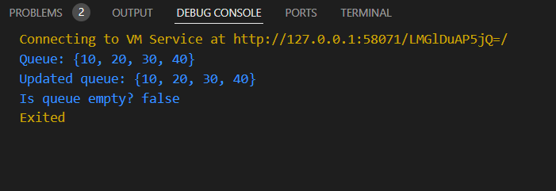

## **After implementation (With accessing the first and last element and removing the last element and clearing the queue)**

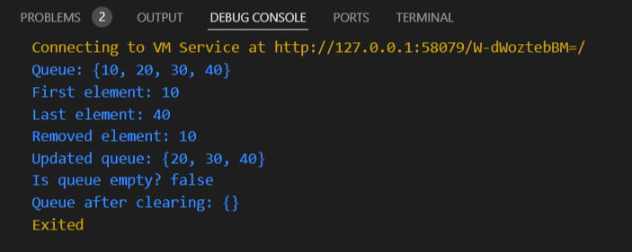

# **How to submit your workshop**

Push your project back to the same git branch using command:

<command name>

# **Happy Coding!**